UF1: Sistemes ERP-CRM. Implantació.
NF1: Identificació de sistemes ERP-CRM
EA1: Instal·lació NAV
Pràctica 1

Índex
Instal·lació de NAV 2

Instal·lació de NAV

Installation:

Steps involved installing MS Dynamics NAV 2016:
- Unzip the image Dynamics.90.ES.1769284.DVD
- Double click the Setup.exe in installation package.
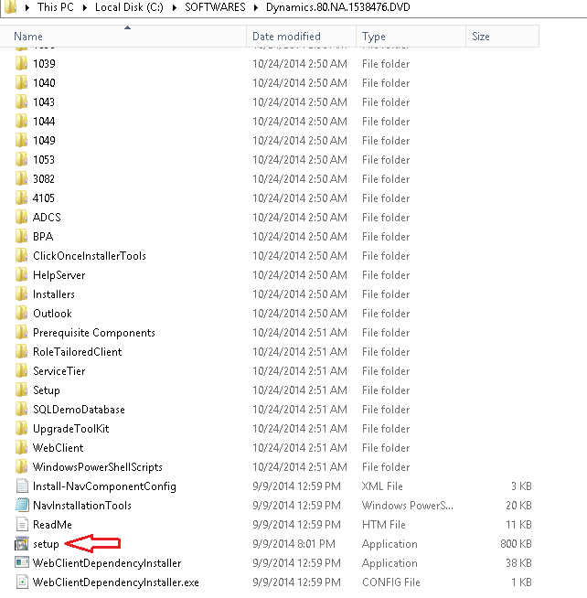

- Click Next button in the window of Dynamics NAV 2016 Installation.
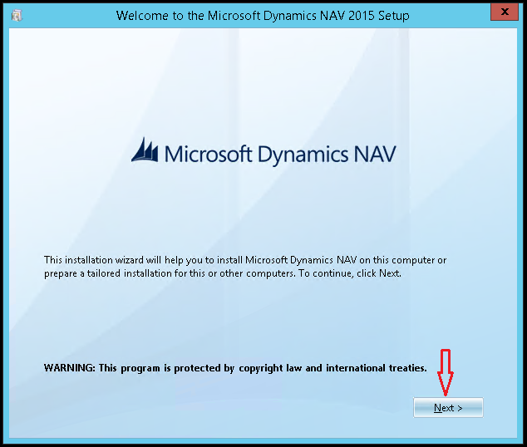

- After reading Terms and Conditions please click “I Accept” button to proceed.
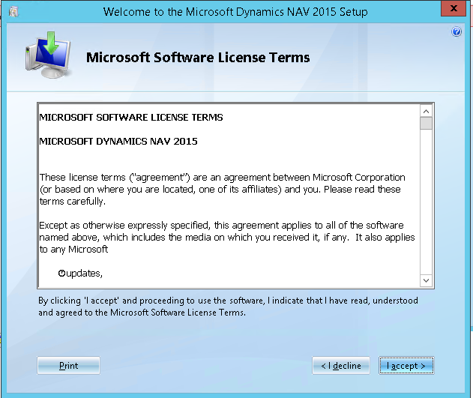

- In the next screen any of two option,
- Demo installation: This is a standard installation type, which will install NAV 2016 Server, NAV 2016 Client, NAV 2016 development environment, MS Office Add-on for Dynamics NAV 2016, and a demonstration database with demonstration license.
- Choose an installation option: This will give you custom settings for Dynamics NAV 2016. Choose this option to continue.
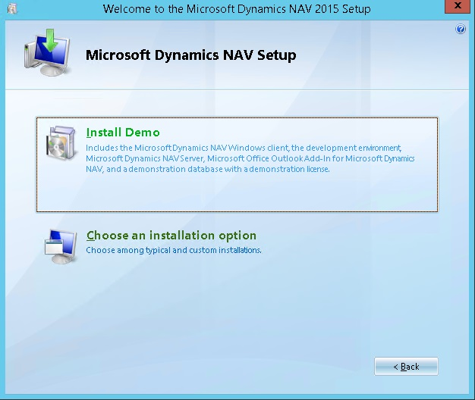

- If you have selected 2nd option in Step 4 you can see the screen which will give you control to customize each feature installation, i.e. Client, Server, Developer.
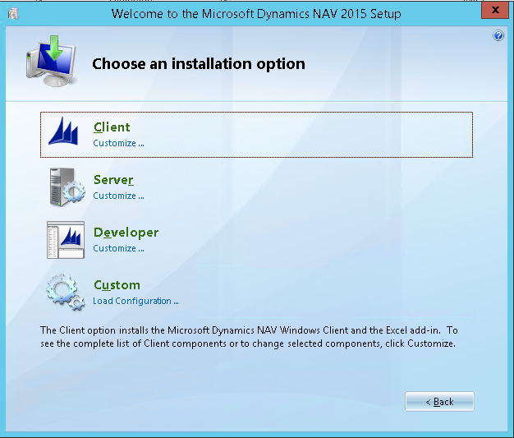
- So, choose Custom Option in above screen, next screen has all the available features for Dynamics NAV 2016.
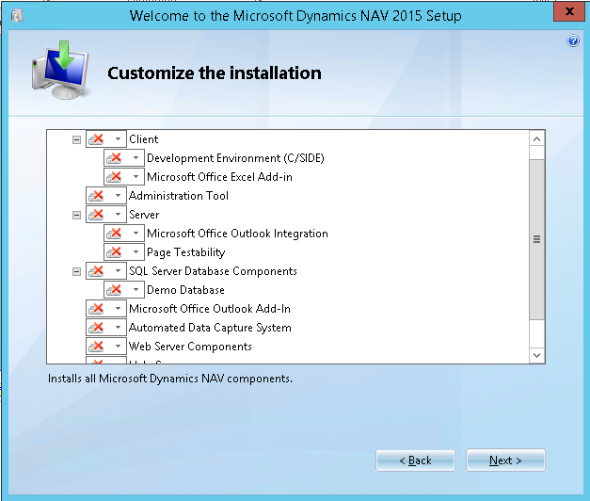
- Now choose that all the features must be executed from MyComputer.

- Next screen will show the required parameters, here you can change the parameters like
  - Installation directories of Dynamics NAV 2016, by default it will install under root drive as below:
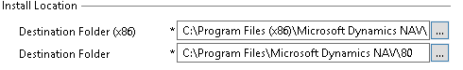
  - You can change following parameter “SOAP Service Enabled” to “Yes” by default it was set to “No”
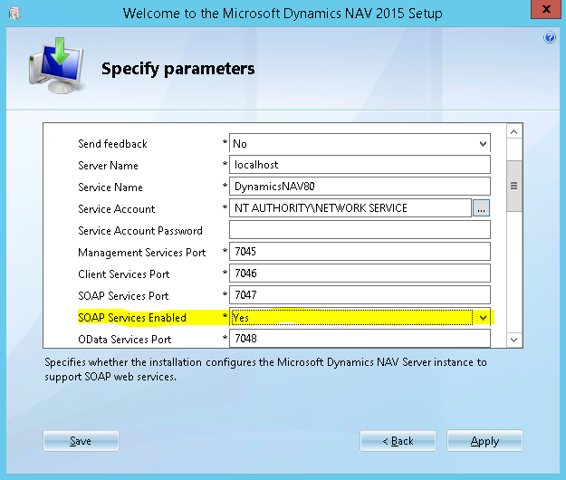

  - Then Delete SQL Server Instance name, and give a name as per your wish for the SQL Server Instance for NAV 2016 Database. Otherwise Setup will create another SQL Server Instance, and there NAV 2016 database will be created. There is no harm if anyone chooses to create a separate instance of Dynamics NAV 2016.
  - Next, we have to specify the Database name, as it will install the Demo Database e.g. Demo Database NAV 2016 (AMS2-xx)
  - Then Click “Apply” button in below of the screen.

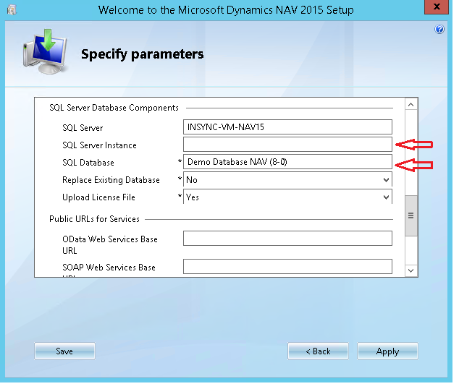
- Next screen you may get a warning of not having a prerequisite “Windows Search”. You can ignore this warning as you are just installing a Demo Environment for Dynamics NAV 2016. If you don’t install Help Server, this prerequisite is not required. After ignoring this error “Help Server” Feature will not install.
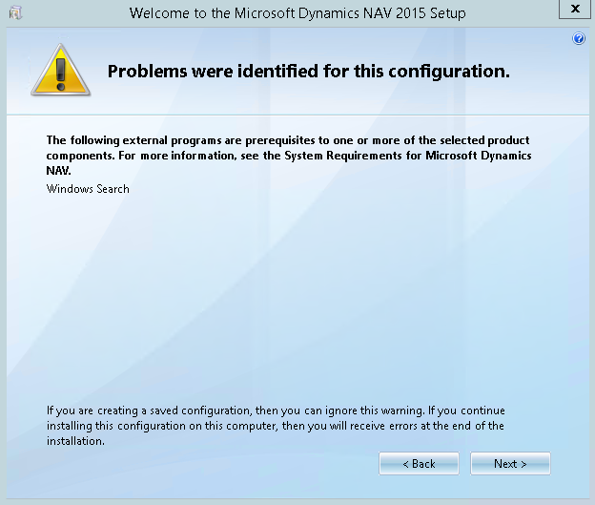
10. Then Click Next Button and installation will start. The Next screen will show the status about installation of Dynamics NAV 2016.
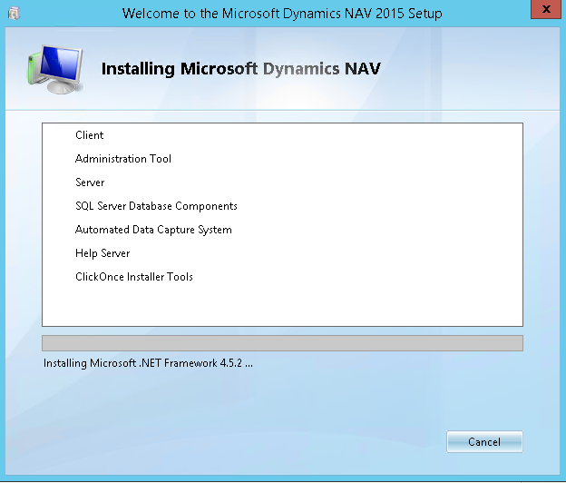
11. It takes around 15 minutes to complete the installation. After completion of installation, installation report can be seen. You can see here, Help Server is not installed, as this system does not contain “Window Search”. It’s Ok for you, later you can install Help Server if you require this feature.
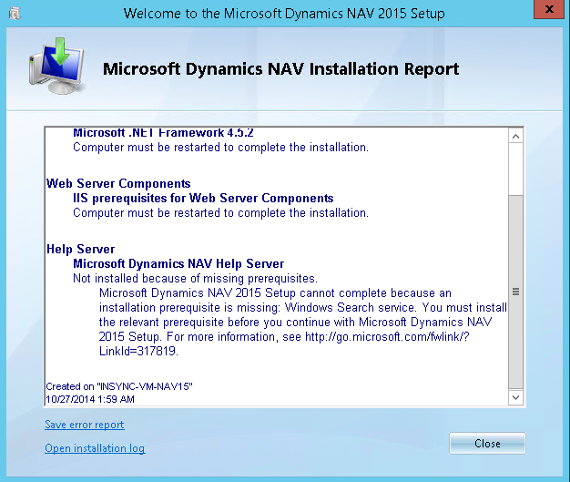
As Dynamics NAV 2016 is installed successfully, you need to verify if it is working properly, by checking the features during installation.

Practice:
Realize the process of installation previous.
Modify this file if in the process of installation have acute to realize any other task, for that it remain evidence of the actions realized (add or deletes points of performance to the document).
Realize the following checking:
As Dynamics NAV 2016 is installed successfully, you need to verify if it is working properly, by checking the features during installation.
  - Open an SQL Server Manager and checking the Database is created or not. (Image from SQL Server 2014 Management Studio)
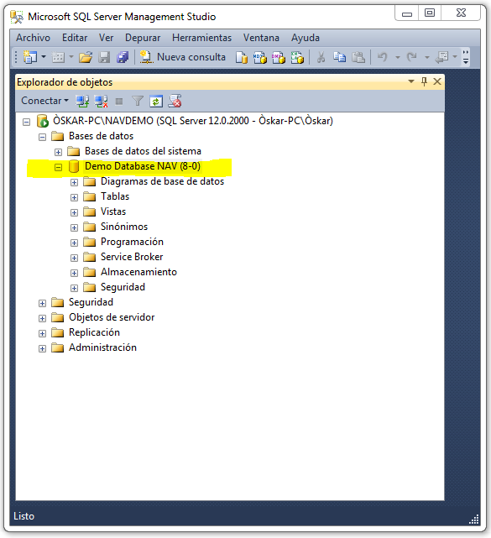

  - Next Checking NAV 2016 Windows Service is installed or not, and you can see it’s installed and running properly.
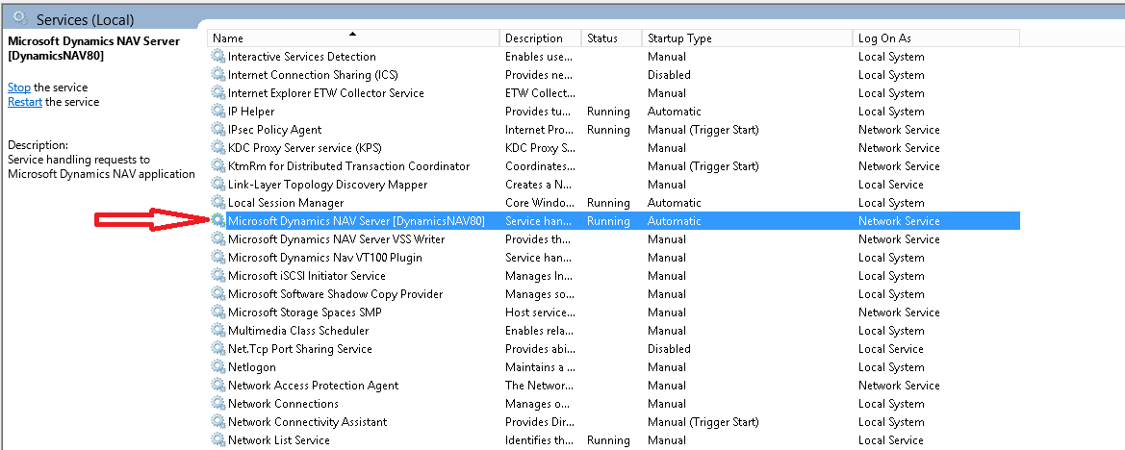
Everything looks fine; now you must check Dynamics NAV 2016 RTC Client, click on Dynamics NAV 2016 icon in start menu. RTC Client will look like next image.
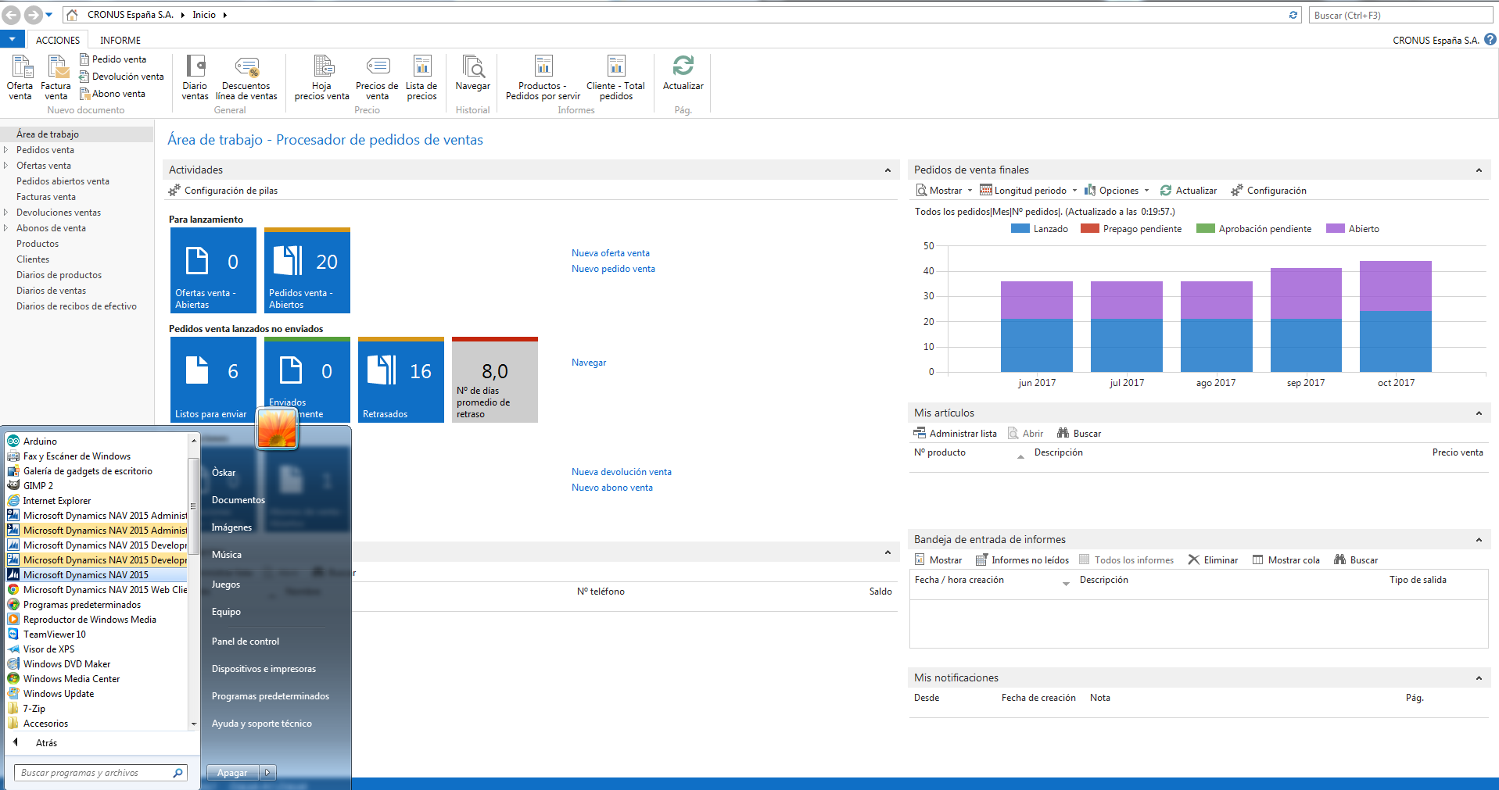

We can check Server Address and Available Companies.

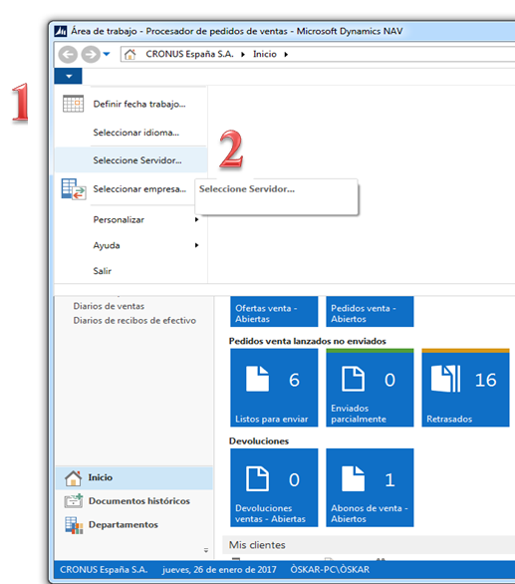

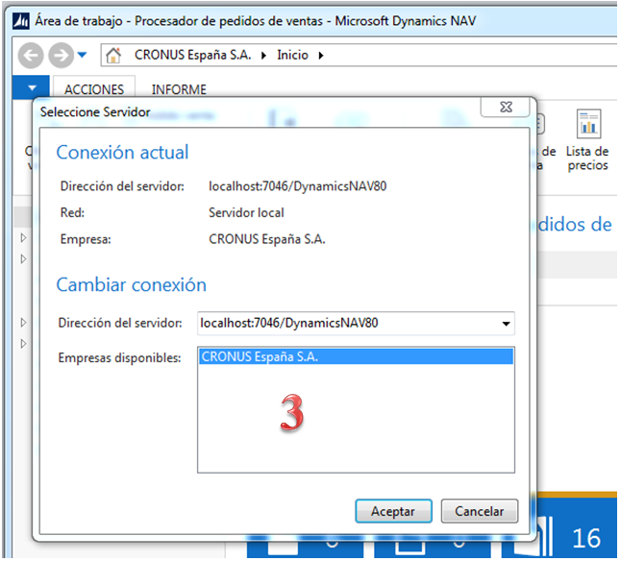

Let’s check now the Development Environment of NAV 2016.

First, click on File→DataBase→Open

Then select the proper Database Name and Authentication

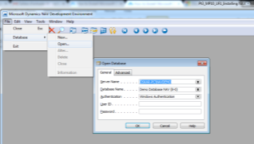

Take a view of the Object Designer items

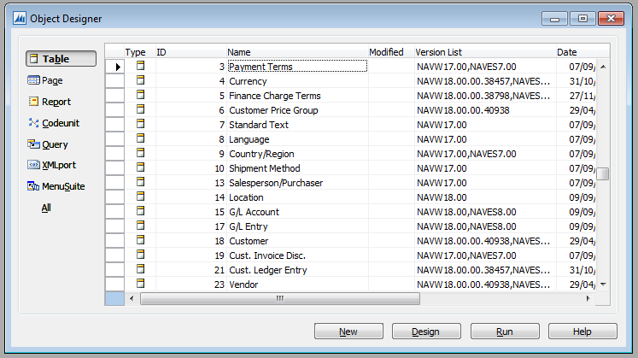

Everything is looking fine, that means installation is correct. Now our last but least concern about web services of Dynamics NAV 2016, so check Dynamics NAV 2016 System Services web service.

Url: hhttp://localhost:7047/DynamicsNAV90/WS/Services

Copy paste above url to your favorite browser, If Webservice of Dynamics NAV 2016 feature is installed properly, we can see following WSDL screen in browser.

Now, you can be assured that Dynamics NAV 2016 is installed properly. If any extra feature is required in future like, Office Add-on for Dynamics NAV 2016, Help Server etc. We can always update the Dynamics NAV 2016 by running Setup application once again.

When finished notify yours teachers to check your progress.

CAPTURAS DEL NAVISION:

